**The Pennsylvania State University**

**School of Science Engineering & Technology**

**Electrical Engineering**

Implementing Flanging Effects in Simulink

Prepared By: Juan Enrique Aguirre

Prepared For: Dr. Morales Aldo

Topics in Digital Signal Processing EE 553

June 16, 2019

**ABSTRACT**

**As part of one of many DSP application, we have audio processing. Audio processing covers many diverse fields, all involved in presenting sound to human hearers. An example is presented in this project by using the flanging sound effect on our sample audio file built upon Simulink blocks.**

**INTRODUCTION**

Among many sound effects, we are exploring the flanging effect. First we have to consider what is a flanging. Described in our notes, we understand that it was created by feeding the same musical piece to two tape recorder. Then combining their delayed outputs while varying the difference in time for it to slow down one of the tape recorders by pressing the thumb on the flange of the feed reel leading to the name flanging [1]. It is also known as a filter that alters the frequency content of a signal by sampling its input, delaying it with a variable delay, and then adding the result to the unmodified input as shown in Fig1.

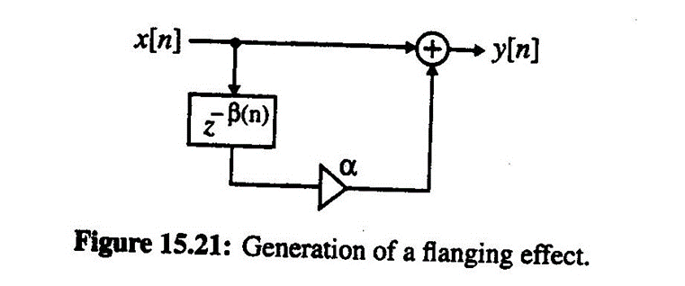

*Figure 1: System Block Diagram Generating the Flanging Effect.*

Where the corresponding input-output relation is then given by (1), our delay $β(n)$ varies periodically between 0 and R, with low frequency $w_{0}$ shown on (2). Note that a flanger filter differs from a traditional comb filter in that the frequencies that it attenuates vary with time.

$$y\left[n\right]=x\left[n\right]+αx\left[x-β\left(n\right)\right] \left(1\right)$$

$$β\left(n\right)=\frac{R}{2}\left(1-\cos\left(w_{0}n\right)\right) (2)$$

**THEORY**

Our flanging effect is similar to a chorus effect in the sense of creating a copy of the original signal and delaying it. However, flanging is delayed in time very slightly, usually no more than 20 milliseconds [2]. The delay time also changes at a constant rate. Due to these copies of audio being identical, interference will occur. By having some noticeable resonances at particular frequencies, these series of notches will also be created across the frequency spectrum. A low frequency oscillator “LFO” is used to control the value of the delay. Through destructive and constructive interference, certain frequencies are either attenuated or amplified when we add the signals. The attenuated frequencies are described by (3).

$$f_{z}=\frac{2n+1}{2∆t} \left(3\right)$$

n = 0, 1, 2, ... Thus, the frequencies that are attenuated are harmonically associated and depend on the instantaneous delay. The constant change of destructed frequencies, “notches” in the frequency response, is perceived by our hearing as a “whooshing” sound that is distinctive of common flangers [3]. If this instant delay is greater than 50 milliseconds, the resulting signal could be perceived as an echo, on the other hand if the delay is usually less than 10 milliseconds, the resulting signal is too fast for the ear to distinguish.

**IMPLEMENTATION**

**Building the Simulink blocks “Flanging Effect”**

#### Using the notes in class, from the reverberation Simulink system we start building blocks. More specifically, we are taking the fractional delay approach. The overall system block diagram can be seen in Fig.2.

#### 

*Figure 2: Simulink Flanging System.*

#### From left to right, we have the following blocks our input wave source “song”, Thunderstruck by AC/DC, containing a sample per audio channel of 2048, and a single data type. The LFO is used to control the value of the delay. We must keep in mind that keeping the same samples per frame with the input signal, we can vary the amplitude, frequency, sample time, and sample mode. We can find more details of each block set up in our Appendix A. The frequency is set at 0.7Hz, amplitude 20, on a discrete sample mode. I also played with continuous mode but this waveform approach ignored the sample time through the simulation sounded the same. I started with a sample time of 1/50. A DC offset delay block with a constant of 20 was fed together with the LFO as the delay input in our variable fractional delay block. Here we maintain the single data type having a linear interpolation mode with input processing “frame based” columns as channels. The fractional delay takes the original song with a delay wave at a particular rate and implements it later in our mixer with the unmodified input. This is explained earlier, like the “two tapes recorders on top of each other one with some small delay”. Lastly, we want to experience and observe the result of our flanging effect by using a combination of scopes the vector scope, the spectrum scope, and the wave device.

**Building the Original Signal**

#### For comparison purposes, to make sure we got a good flanging effect, we ran a separate Simulink block just with the original input wave source “song” directly with our wave device, spectrum scope, and vector scope as seen on Figure 3. This allowed me to play around with some of the parameters of my fractional delay, LFO, and DC offset, to make sure I got a good sounding flanging effect.

#### 

*Figure 3: Simulink Original Audio.*

**RESULTS**

For the following results, I will be using two audio files one being the Blue Harp, the other one Thunderstruck. This is because different songs will have different spectrums however, we will observe the same behavior by comparing their original audio vs flanging effect.

#### 

*Figure 4: Vector Scope “Blue Harp” Comparison*

#### In Figure 4, we observed our vector scope on the left side from our original input signal. On the right side after going through our flanging system, we observed an increase in amplitude and some resonances due to amplified harmonics from our mixer.

#### 

*Figure 5: Spectrum Scope “Blue Harp” Comparison*

In our Spectrum Scope Figure 5, on the left side, we have the original audio. On the right side, we have the modified signal from our flanging system. In this particular graph on the frequency domain, we observe that we maintain the same audible frequency range 0-9KHz. However, the important intake as explained in our theory is that we can see frequencies that are attenuated this is because it depends on the instantaneous delay. The constant change of destructed frequencies, “notches” in the frequency response, is perceived by our hearing as a “whooshing”. If we were to count, we would see more peaks.

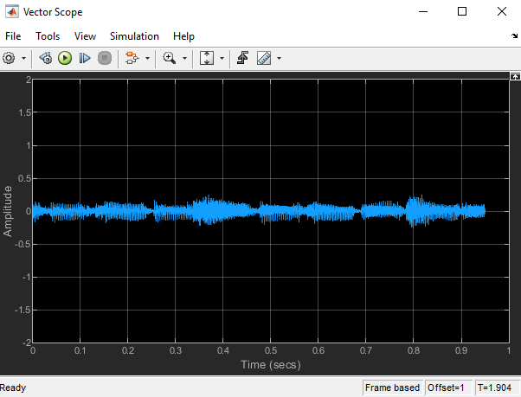 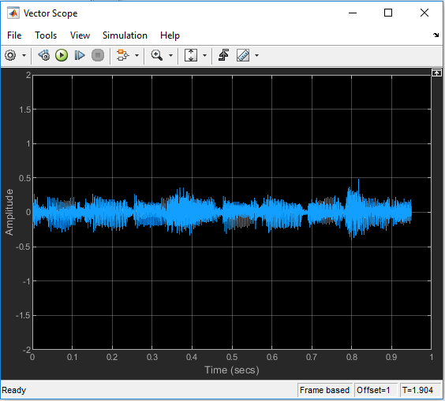

*Figure 6: Vector Scope “Thunderstruck” Comparison*

In our second song sample, we observed the same behavior even though the song already contains some effects on the electric guitar.

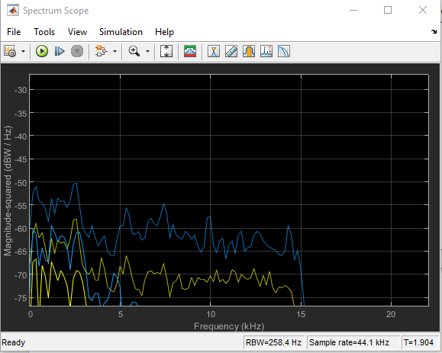 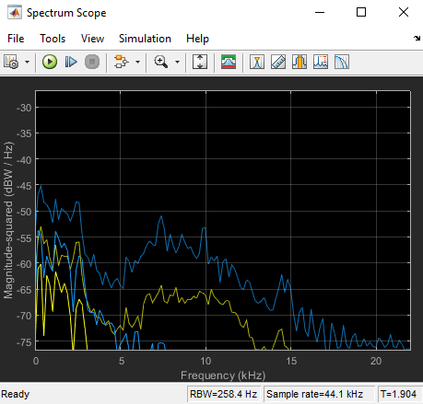

*Figure 7: Spectrum Scope “Thunderstruck” Comparison*

Similar to our previous conclusion, I noticed some extra range on the frequency spectrum from those higher notes. Perhaps this was more noticeable because of the type of input signal. The original pretty much has a cut off frequency at 15KHz, versus the modified audio extends a little more.

Another result to consider is the audio itself. From our wave device, I was able to experience firsthand, by trial and error, modifying different parameters and running the simulation while comparing the original audio to dial down a good “jet sound”. I noticed that understanding the original audio input is important for it to work better. Some sounds are more noticeable than others when we use the effects.

**CONCLUSIONS**

This practical use of DSP for audio applications effects shows how common we see this around us. The Flanging effect or “whooshing jet sound” from a mixer of the original superposed with its delay was dynamic using Simulink blocks. There is a whole area in audio/sound engineering, because even though we use only one effect, I had to vary different parameters depending on the input signal. In some cases the fractional delay with the LFO and the DC offset delay block required multiple trials in order to achieve a good sounding effect. I can only imagine when they introduce sound studios and equipment to accomplish a combination of different effects. Besides hearing, we observed side by side difference between original sound and modified sound on the frequency spectrum and vector scope. We notice an increase in amplitude, notches, and peaks due cause by colliding harmonics either amplifying or destructing, as well as attenuated frequencies due to instant delay. Lastly, an emphasis on understanding human hearing is relevant. This was the case when I noticed that understanding that some audio files were more suitable to use with this particular effect.

**REFERENCES**

[1] L. Jackson, Digital Filters and Signal Processing, 3rd. edition

[2] Borisoff, Jason. “Phase, Flanger, and Chorus Effect Pedals.” *Making Music Magazine*, Making Music Magazine, 18 Apr. 2019, makingmusicmag.com/difference-between-phase- flanger-and- chorus-effect/.

[3] Turner, John. “Putting Theory into Practice with Simulink .” *Semanticscholar.org*, University of Portland, 2005, pdfs.semanticscholar.org/5b47/9ff9405a166022dc92426fb93c7587ee01ea.pdf.

**Appendix -A**

**LFO**

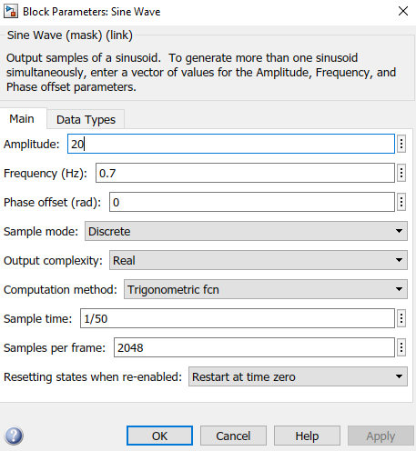

**Variable Fractional Delay**

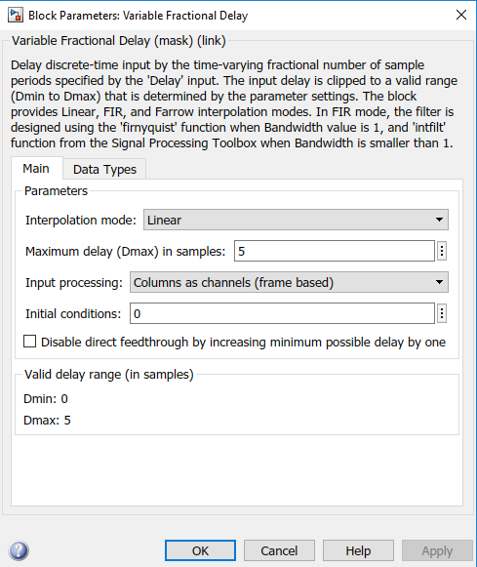

**Song**

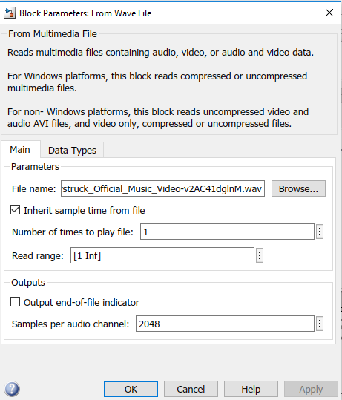

**Wave device**



 